

**INDIAN INSTITUTE OF INFORMATION TECHNOLOGY NAGPUR**

**Name**:- Uma

**Enrolment No**.-BT20ECE044

**Course**-CMOS

**Instructor**-Dr.Paritosh Peshwe

CMOS Project Report

4-Bit Arithmetic Logic Unit (ALU)

### **Introduction**

This report describes designing and implementing a 4-bit layout in Microwind software that performs XOR, AND, OR, addition, and subtraction operations on two 4-bit inputs. Additionally, a netlist was written for the same design in NGSpice. This project aims to demonstrate the design process and implementation of digital circuits using Microwind and NGSpice.

### **Design Methodology**

* The design process began with identifying the required operations and their corresponding Boolean expressions.
* Next, the logic gates required to implement the operations were selected, and a schematic diagram was drawn using Microwind software. The layout of the schematic was then designed, keeping in mind the physical constraints of the chip, such as metal widths and proximity between gates. CMOS 0.18 micro meter technology is used. The final design was then simulated and verified to ensure its correctness.
* After the design was verified, a netlist was written for the circuit in NGSpice, which allows the simulation of the circuit's behavior under different input conditions. The netlist was then run in NGSpice to verify the circuit's functionality.

### **Implementation Details**

* The 4-bit layout was implemented using the following logic gates:

1. XOR gate
2. AND gate
3. OR gate
4. Full-adder
5. Full-subtractor

* These logic gates were implemented using various combinations of basic digital components, including inverters with PMOS, NMOS, and transmission gates consisting of NMOS.

The layout was designed using Microwind software and consists of 52 gates in total, including 4 XOR gates, 4 AND gates, 4 OR gates, 4 full adders, 4 full subtractors, and 32 CMOS inverters. A total of 32 PMOS devices and 136 NMOS devices have been used.

Transmission gates were used to reduce the number of MOSFETs required in the circuit. The use of these components in the design helped to minimize the size and power consumption of the layout.

### **Netlist:**

The netlist for the circuit was written in NGSpice and consisted of the following components:

#### **Full Adder**:

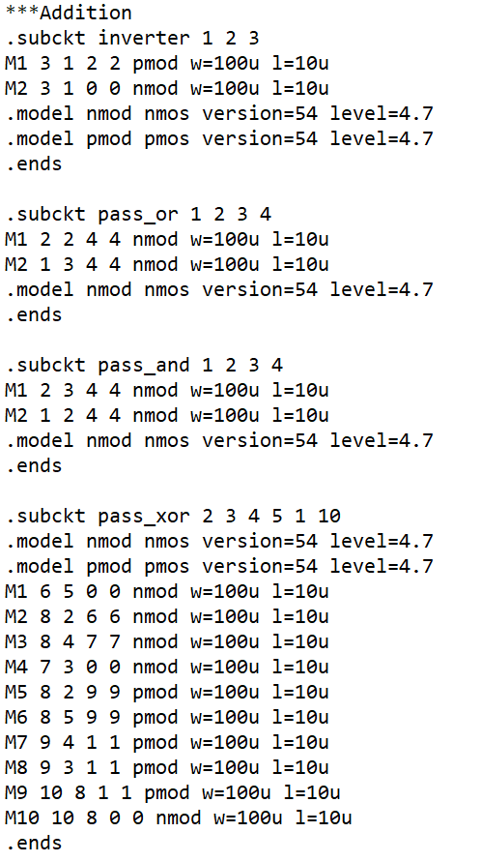

### 

### 

### 

### 

### 

### 

### 

#### 

#### 

#### **Full Subtractor**:

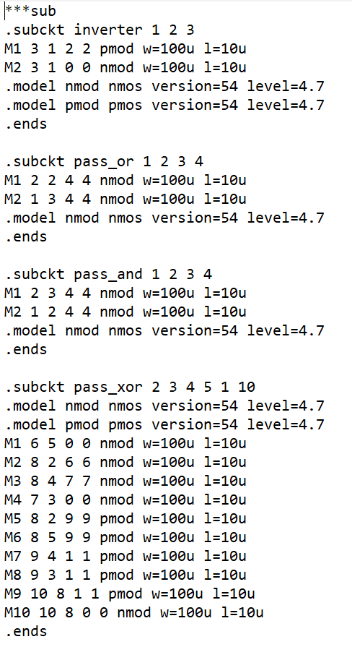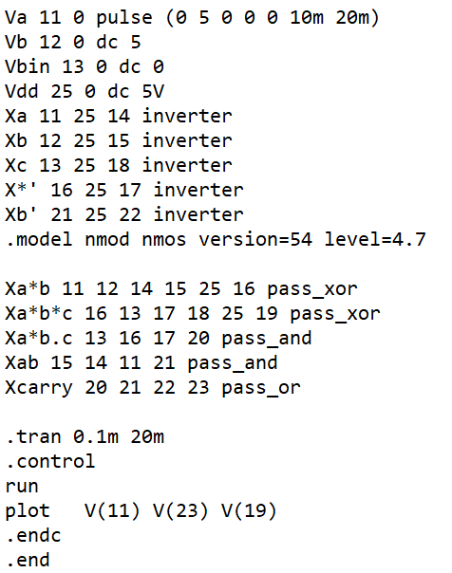

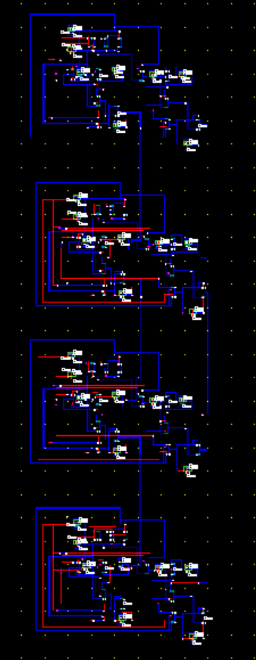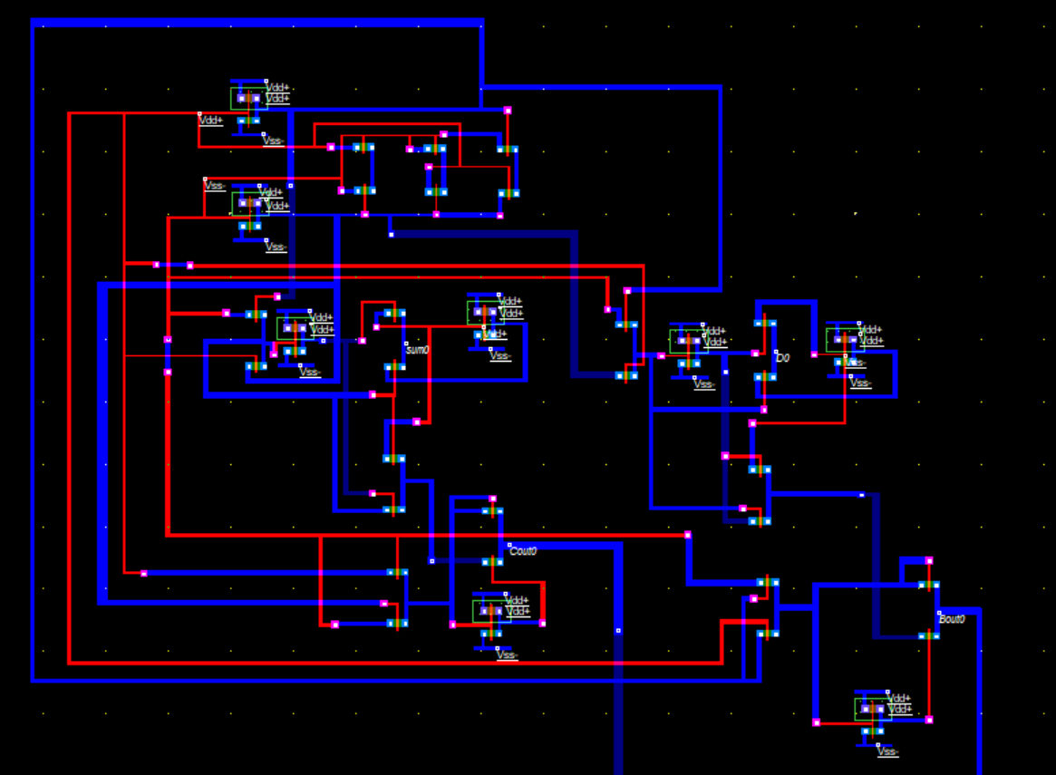

### 

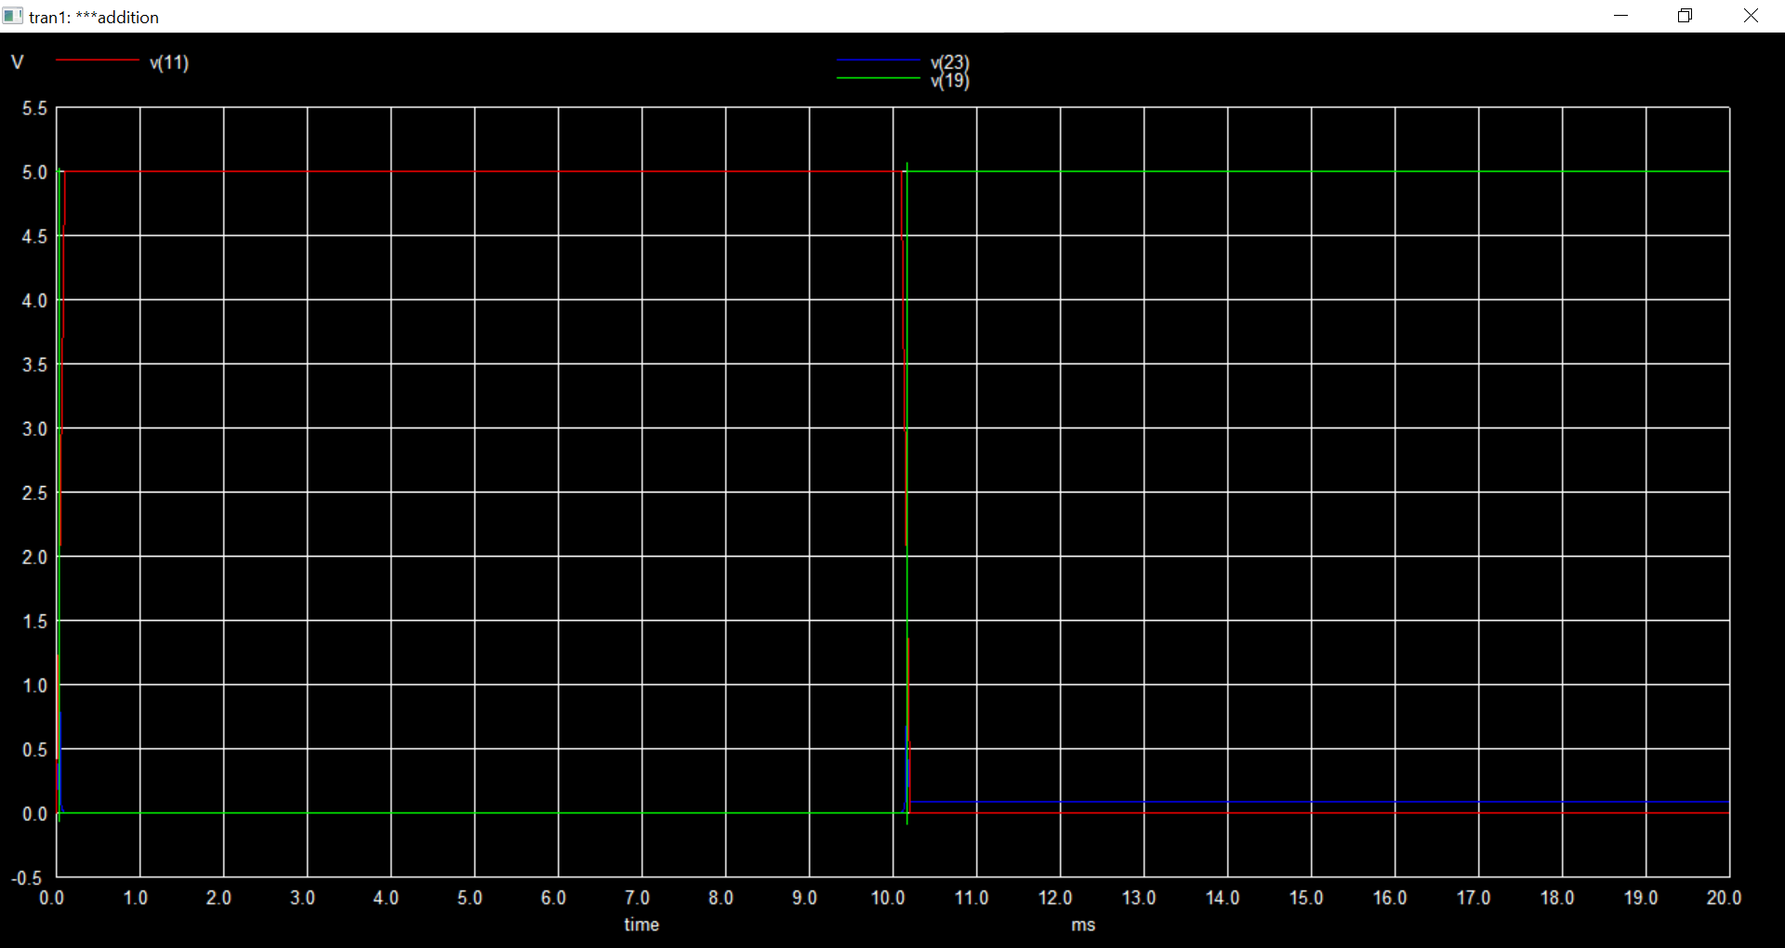

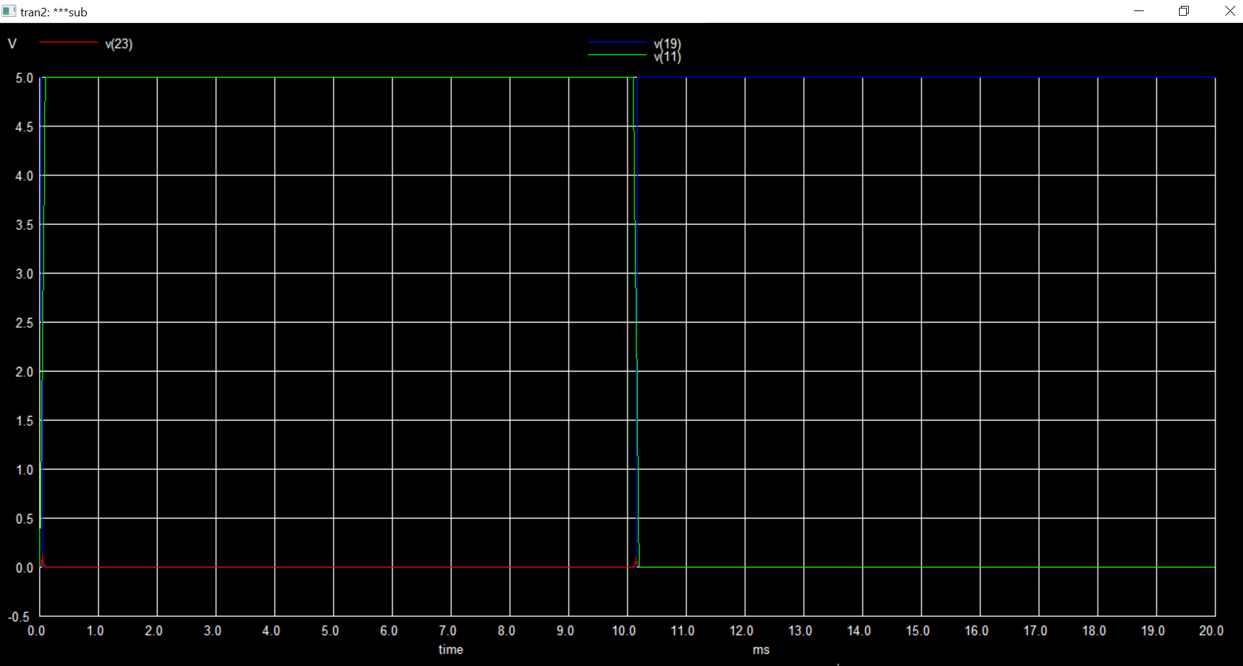

### **Results and Conclusion**

The 4-bit layout design and implementation were successful, and the netlist simulation in NGSpice verified its correctness. The circuit could perform XOR, AND, OR, addition, and subtraction operations on two 4-bit inputs as intended.

In conclusion, the design and implementation of the 4-bit layout using Microwind and NGSpice demonstrated the process of digital circuit design and simulation.